[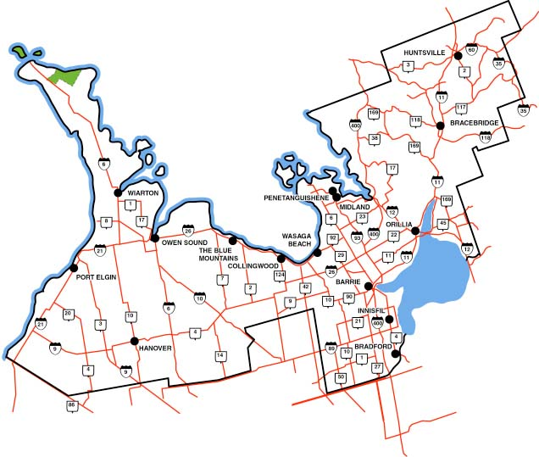](http://www.google.ca/url?sa=i&rct=j&q=&esrc=s&source=images&cd=&cad=rja&uact=8&ved=0CAcQjRxqFQoTCLmswKSa28YCFYhVPgod0B0ALw&url=http://www.out-there.com/ton02trm.htm&ei=uk6lVbnnKYir-QHQu4D4Ag&bvm=bv.97653015,d.eXY&psig=AFQjCNFjHGvLbEDyL-aI93yD99jO-Lcr9g&ust=1436983043408142)

Bruce Peninsula Wasaga beach Muskoka cottage country Kawartha Lakes Simcoe Lake

Lake Simcoe - 1 h north of Toronto, 20 minutes from Aurora.

Muskoka or Cottage country - Muskokaa is a scenic area sprinkled with picturesque villages and towns

Wasaga beach - the longest freshwater beach in the world

Bruce Peninsula - 3- 4h away, beautiful place

Niagara on the lae

Kawartha lakes